**TMA TM341**

**Name**: Ahmed Mohamed Abdullatif Rifai.

**ID**: 1851711008.

**Question 1**

1. **Read uttower1 and uttower2 images in the attached file as img1 and img2 then display the two images horizontally as indicated below:**

1. **Apply SIFT feature extraction on the above two images and display the number of detected features:**
2. **Apply Brute Force Matcher on the above two images and display SIFT matches:**

1. **Find the homography between two images, Warp img2 onto img1 using the homography matrix and Overlay img1 onto the resulting image (creating the panorama) and prove that the output will be as follows:**

**Question 2**

1. **Read a jpg image of your choice and convert it to grayscale.**
2. **Apply a Gaussian Blur to the grayscale image and display the blurred image.**

1. **Detect edges in the image using the Canny edge detection algorithm and show the edges.**

1. **Perform image thresholding using Otsu’s method and show the thresholded image.**

1. **Detect contours in the thresholded image, draw them on the original image, and display the result.**

1. **Resize the original image to half its original dimensions, then perform a downscale operation and display the results.**

1. **Apply a Morphological operation on the thresholded image, and show the output.**

**Question 3**

1. **Object Localization with TensorFlow**

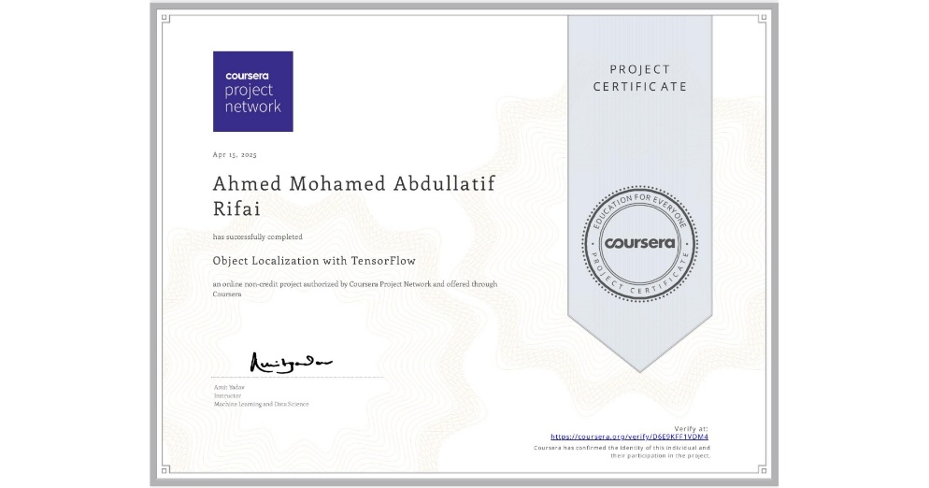

1. **Aerial Image Segmentation with PyTorch**

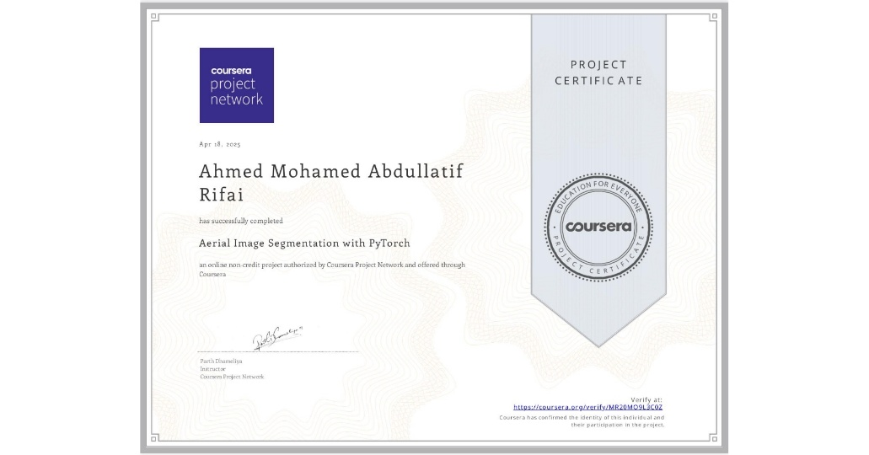

**Guide Notes:**

**You can download the code file (Q1, Q2) by double-clicking the attached .ipynb file.**



**Feel free to adjust the images included in the file as desired.**

**Here's the GitHub link for this project:** [**Eng-Ahmed-Rifai/Computer-Vision-Algos-Applications**](github.com/Eng-Ahmed-Rifai/Computer-Vision-Algos-Applications)